**Developer A: Faiq-> just to push new changes on the git**

* Move to a directory which you want to push and you just want to push all the files except, folder_suspicious

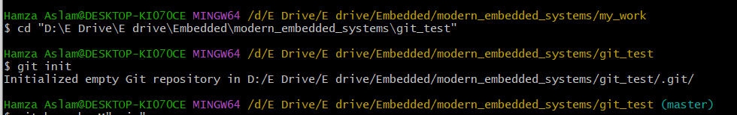

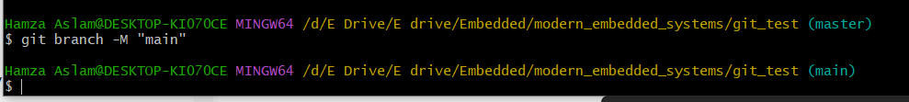

* Add .gitignore file and in .gitignore file use vim editor and add folder named folder_suspicious





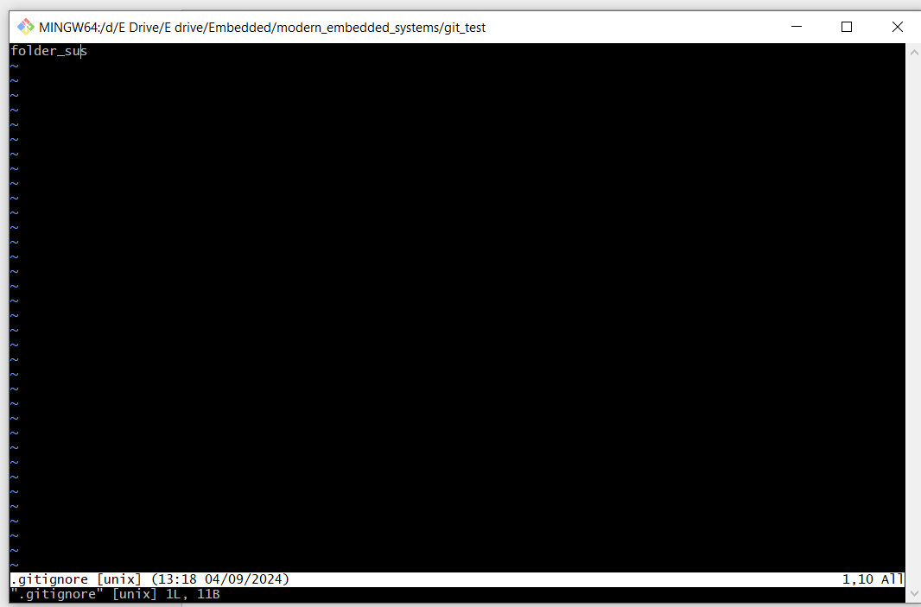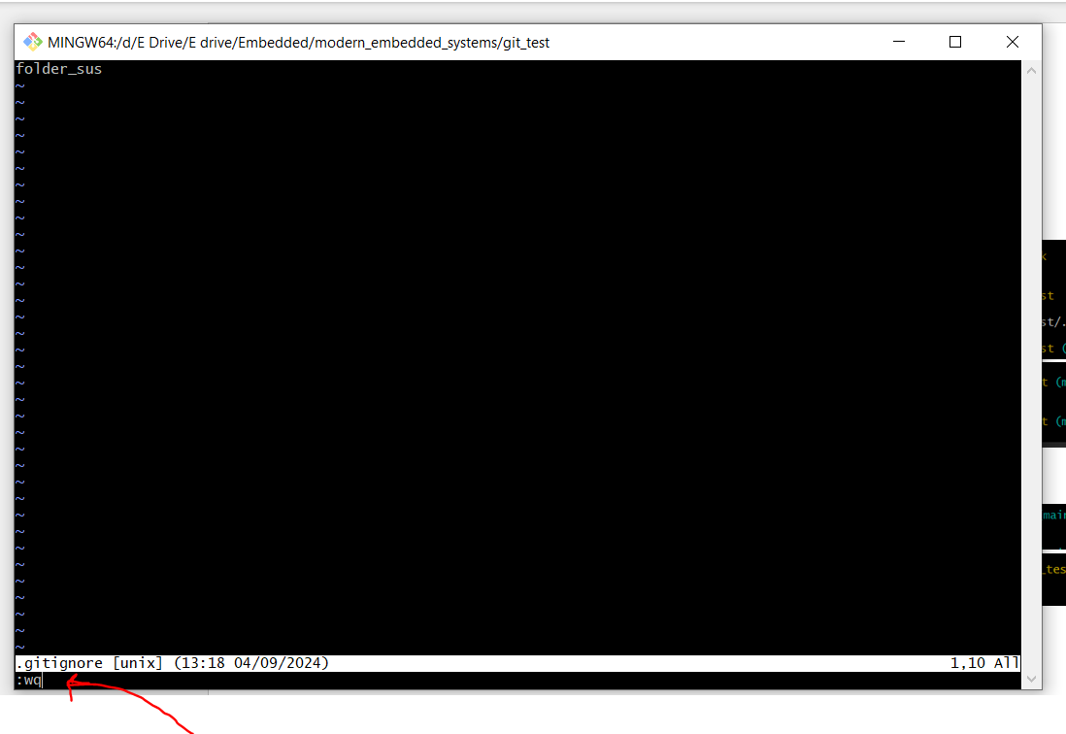

* Set the origin(github directory) to push

* If the directories have some related history then you pull and then add commit and then push but here we need to use this command **git pull origin main--allow-unrelated-histories**

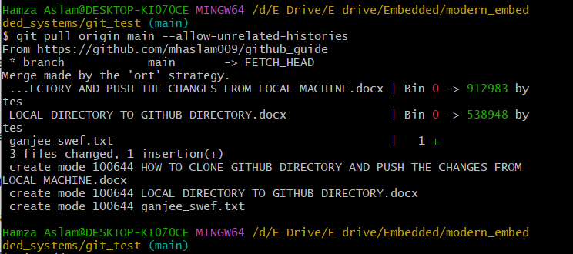

* **Now add, commit and push**

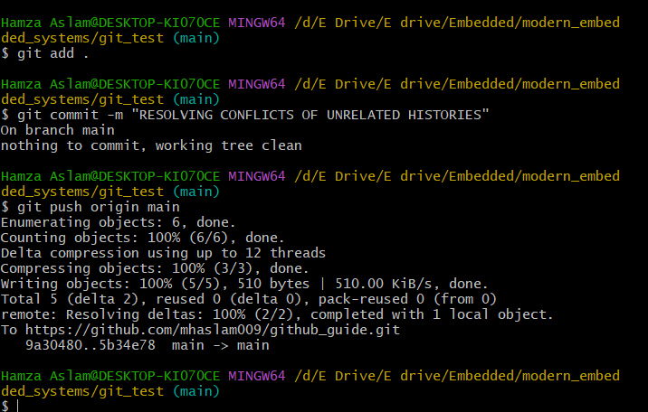

* **Verification:**

**IMPORTANT NOTE:**

**GITHUB DON’T PUSH EMPTY FOLDERS**